10 Things You Might Not Know About Poverty In Canada
October 17, 2013
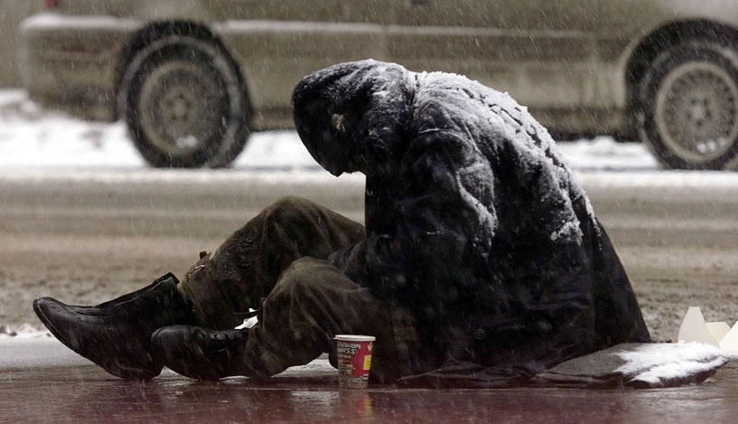

10. It's hard to measure
There is no official measure of poverty in Canada. Statistics Canada reports that 14.9 per cent of Canadians have "low income" (i.e. make less than half the median income) but declines to label that group "poor." Low income is only one way of measuring poverty, though; another is the "basic needs poverty measure," which looks at the absolute minimum resources needed to fulfill physical well-being. In 2008, the Organization for Economic Co-operation and Development (OECD) noted that poverty had been steadily rising in Canada since the mid-1990s.

9. It varies widely between different groups
Regardless of how you try to measure poverty, certain groups are worse off than others. A study by the Canadian Centre for Policy Alternatives found that Aboriginal Canadians make about 30 per cent less than the rest of Canadians. Other groups more likely to be affected by poverty include single parents, recent immigrants, people with disabilities and seniors, according to Statistics Canada.

8. Child poverty is high in Canada
According to the report, 13.3 per cent of Canadian children live in poverty, compared to 11 per cent across the 35 "economically advanced countries" studied. According to one study, half of First Nations children in Canada live in poverty.

7. It's a significant burden on the economy
Poverty can exert extra health care, crime and social assistance costs. According to an estimate from the Ontario Association of Food Banks pegs the national health care costs attributable to poverty at $7.6 billion.

6. Many Canadians spend too much on shelter
3.3 million household in Canada are paying more than they should on housing, according to data from the National Household Survey released this year.

5. Poverty can shorten your life
An analysis by The Hamilton Spectator showed that there was a 21-year gap in life expectancy between that city's richest and poorest neighbourhoods.

4. Many don't have enough to eat
According to Food Banks Canada, nearly 900,000 Canadians are assisted by food banks each month. Thirty-eight per cent of those helped by food banks are children and youth and 11 per cent are Aboriginal (compared to 4.3 per cent of the total population).

3. Homelessness is widespread
As many as 200,000 Canadians will experience homelessness each year, according to a recent report from the Canadian Homelessness Research Network. On any given night, about 30,000 Canadians are homeless.

2. Debt levels are on the rise
Last month, Statistics Canada reported that the Canadian household debt-to-income ratio had climbed to a new high of 163.4 per cent — in other words, the average Canadian owes $1.63 for every dollar they earn.

1. Early investment can yield big gains/profits
A 2008 report from the Public Health Agency of Canada argues that reducing child poverty can have huge spillover effects on society. "It is estimated that $1 invested in the early years saves between $3 and $9 in future spending on the health and criminal justice systems, as well as on social assistance," the report says.

