Residential School Survivors Share Their Stories

Truth and Reconciliation Commission hears testimonials at Eskasoni
by JOYCE MACDONALD

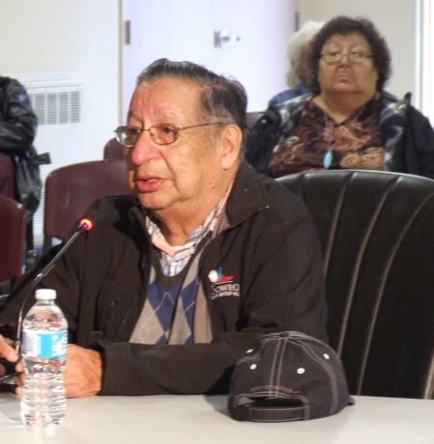
Grand Chief Ben Sylliboy of Waycobah. photo by Joyce MacDonald
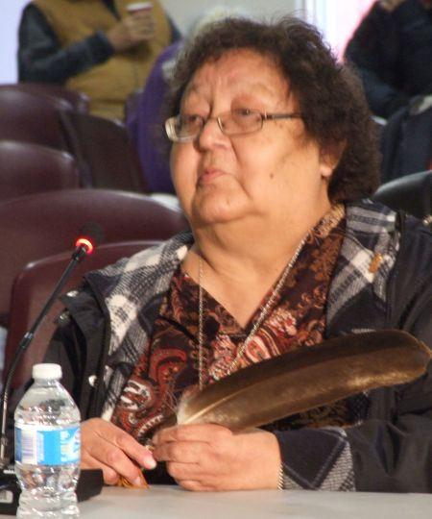
Margaret Poulette of Waycobah. photo by Joyce MacDonald

The Truth and Reconciliation Commission of Canada held a national event in Halifax October 26 to 29 at the World Trade and Convention Centre. Everyone, both Native and non-Native, was welcome to attend. This is a report from the hearing in Eskasoni, Cape Breton.
Truth can be an ugly thing.
It was to hear some ugly truths that people gathered in Eskasoni on Friday, October 14th for a session of the Truth and Reconciliation Commission of Canada. The commission is holding hearings on Indian Residential Schools across Canada. The Canadian government supported more than 130 such schools for over a century, during which they were run by a variety of Christian churches. These schools took children from their parents at a young age for the explicit purpose of destroying First Nations cultures, languages and ways of life.
The Truth and Reconciliation Commission invited anyone involved in or affected by the residential schools to make a presentation. Most of the speakers were survivors who attended the Shubenacadie Indian Residential School, which was the only such school in Atlantic Canada. It was in operation from 1923 to 1967.
Benji Lafford, a survivor from Eskasoni, spoke about being taking to the train station by uniformed government officials at the age of six.
“I was an ordinary child,” he said. “I went to school in Eskasoni for a while. I didn’t understand anything about the English language at the time. Mostly we were speaking Mi’kmaq. When my dad was alive, he taught us in Mi’kmaq. We chopped wood, we would get water, we would make sure everything would be okay for the next day so we wouldn’t be hungry or cold for the winter. As a young boy, I didn’t understand why they took me away from my homeland and from parents.”
Lafford and his brothers and sisters were all sent to the residential school. He said that as a child he wondered what he did wrong.
“I know now that we didn’t do anything wrong because we were innocent,” he said. “We stopped at almost every train station. We saw a lot of Native children standing on the side of platform. There were no families, no relatives, no uncles, grandfathers, nobody to say goodbye to them. No hugs. There were a lot of children crying.”
Upon arrival at the school, the children were met by the nuns and priests who ran it. The boys and girls were separated. They had their clothes taken away and their heads shaved.
“They scrubbed us so hard, trying to take the Indian away from us,” he said. “They said, you have no parents to come and help you. You have no grandparents to help you.”
He said he recalls, in later years, little boys crying as they approached the big red school, and as an older boy, he knew there was no way to help them.
“Once we got locked up behind those closed doors, no turning back. No turning back at all. You can’t run away because they always bring you back,” he said.
The children were not allowed to speak the Mi’kmaq language. Any violations of the rules were punished harshly.
“If you said a word wrong, you were going to get hit on the head, boom! Say your prayers right. Kneel down right,” he said. “We’d get hit on the head when we were saying the rosary at night. After an hour, our kneecaps would get sore.”
One rule was that children were not allowed to go to the bathroom after 10:00 p.m. Lafford said he became a bed-wetter as a result, and was forced to carry his soiled bedclothes on his head through the cafeteria at breakfast time every time it happened.
“They strapped us almost every night,” he said. “Bend down and touch your toes. Take your pants off.”
He described it as “just like being in a cell.” Punishments also included being locked in cupboards. He described being slapped for speaking Mi’kmaq. His mother died while he was at the school, and he remembers being yelled at for crying in bed after he found out.
“Life went by, days went by, years went by,” he said. “I hope to my creator that things like that will never happen to anybody else. It was hard to let go of things that you loved. It’s not easy to be a child and to grow up in a different world. It’s not easy to walk with your head up when your head is down.”
Lafford attended the residential school until it closed in 1967. He finished his schooling in Toronto, and considered staying there, but decided to return to Cape Breton.
“I went back to my community, where I belong, where I can speak my language, to be with my family, my uncles, my aunties, my cousins, my friends,” he said. ‘That’s where I wanted to be.”
However his experiences at the residential school continued to affect him. He said he drank and used drugs when he got older, often ending up in jail. He had difficulty with jobs and relationships. He said he thought about suicide at times. But then everything changed.
“I became a dancer,” he said, “a traditional dancer. I love that powwow music. I like the sound of the drum. I like the sound of the people singing. My life changed. I respect myself, I honour myself and I love myself, who I am today.”
Grand Chief Ben Sylliboy from Waycobah also spoke about his experiences at the residential school, which he attended for four years, starting in 1947. He was six years old and attended with his two sisters.
“My mother ended up with TB in ‘47,” he said. “We were put into the residential school. During that time, there was a thing called centralization, where the people from Whycocomagh were forced to go to Eskasoni to live here. There were nine families that remained in Waycobah, one of which was my parents. We had everything. We had our own farm. My father worked. The only problem was, my father couldn’t look after us. So we ended up going to Shubie.”
He recalls being forced to speak English.
“The only language we knew was Mi’kmaq,” he said. “Being put in an environment where you didn’t know the language, it was a difficult thing. I couldn’t even ask to go to the washroom.”
He said the school officials told the children they would never amount to anything.
“They said, the only good Indian is a dead Indian,” he said. “Even the nuns told me that. That hurt everybody.”
He said the boys in the school stuck together, becoming comrades. But the boys were kept strictly separated from the girls.
“The hardest part was, you weren’t allowed to talk to your sisters,” said Sylliboy. ‘I would have liked to have a little 15 minutes together. But we weren’t even allowed.”
He said when their parents visited, the visit was supervised by a nun, and they were only allowed to speak English. Letters home were also dictated by the nuns, with the children all writing the same thing that was written on the board.
“That’s how we communicated with our parents,” he said. “We couldn’t tell them what was really going on, the beatings we’d take.”
In the winter, children were sent outside regardless of the circumstances.
“I remember one time I had a sore stomach,” he said. “Diarrhea. I knocked on the door and knocked on the door. They wouldn’t open the door for me. So I dirtied myself. Eventually a nun came to the door. She said, what’s wrong? I said, I’ve got a sore stomach. She said, you shouldn’t knock on the door. She banged my hand on the door until you could see the bruises. Here, you can see the scar. That remained with me for 66 years.”
After four years, his mother recovered, and he was able to go home. He contracted tuberculosis and spent four years in hospitals. He credits the elders, including Caroline Gould, with helping him re-learn the Mi’kmaq language and reconnect with Mi’kmaq traditions.
Georgina Doucette of Eskasoni said leaving the residential school was also difficult.
“Coming back into my community,” she said, “I felt as if I didn’t belong. Even my grandmother said of my brother and I when we went to stay with her, she told her friends, you know these children who come out of that school, they’re not right in the head. Those were words from my own grandmother. We no longer spoke the language, we no longer had that connection with family because we separated for so long. We didn’t belong in the White world, and we didn’t belong in our community.”
She said it took her a long time to cope with her experiences, turning to liquor at a young age.
“I passed on that legacy to my children,” she said. “When I sobered up 24 years ago, I looked at them. And I kept apologizing. I feel deep down, this is the road I set for my children, with alcoholism. And their children drink and do drugs. I feel very guilt. It’s hard to shake that guilt when you’ve carried it for so long.”
She said she was unable to talk about the residential school for a long time.
“I never talked about the residential school because I had nothing good to say,” she said. “I never told my children stories of what happened to me. It’s hard for me to try and forgive, but I know deep down I have to forgive myself first.”
She said she is still on a journey of healing, which started with a family powwow and a return to traditional ways.
“The revival of our culture was really needed,” she said. “I’m proud of how far we’ve come, and I know we have a long ways to go. The whole community has to get together. That’s the only way we can get through it, talk about it, cry and move on.”
Margaret (Sylliboy) Poulette of Waycobah went to the residential school at the age of four. She remembers some fun times, such as going swimming in a nearby lake, but even those memories have a sad side to them. She spoke of making herself a doll out of a cleaning cloth, and having the toys sent by her parents taken away by the nuns to be given to an orphanage.
She said she can barely remember a time before the residential school because she was so young when she went there. She says she does recall waiting for her dad to come and get her and take her home.
“You know at night when a car comes up and the light goes round the room,” she said. “That night a car came up and the light went round. I thought it would be him.”
Children were assigned English names and numbers at the school.
“My number was 54,” said Poulette. “I’ve seen a lot of abuse in the classroom. They picked on people who had darker skin.”
She recalled a blind girl being strapped for not being able to read, and a boy who stuttered having his mouth held open by a stick all day. Another boy was punished by having to wear a dress and have the other children feel the bones of his head where the nuns said “his horns were coming out.” Another girl spilled milk and was strapped for it until her hands turned blue. Children who tried to run away were punished by having their heads shaved. Children who vomited at meals were forced to eat the vomit.
She said they did celebrate holidays, such as Christmas.
“I remember making streamers for decorating,” she said, “but Santa never found us there.”
Commissioner Wilton Littlechild said a lot of the stories resonated with his own experiences as a boy attending a residential school on the Prairies. The commission is visiting First Nations communities across the country collecting such accounts.
Prime minister Stephen Harper apologized to residential school survivors on behalf of the Canadian government in 2008.
“I didn’t accept his apology, to be honest with you,” said Benji Lafford, “because it didn’t come from the heart. Someone just wrote that on a paper and said, read that to the survivors of the Indian Residential Schools to ease their pain. A lot of survivors never got to ease their pain.”
The Truth and Reconciliation Commission came out with a court settlement with residential school survivors in 2006.
Commissioner Marie Wilson said the commission aims to share these stories with all Canadians.
“We think it’s non-Native people who don’t know the story, but very often it is also the Aboriginal children and grandchildren who have never been told these stories,” she said. “They don’t have a context for why things have been the way they have been. I think it’s an extremely important transference of knowledge to share that.”
http://halifax.mediacoop.ca/story/residential-school-survivors-share-their-stories/8706

