Province/Territory | Total Population | Province/Territory | Total Population
B.C. | 4 582 000 | N.B. | 756 100
Alberta | 4 025 100 | P.E.I. | 145 200
Sask. | 1 108 300 | N.S. | 940 800
Manitoba | 1 265 000 | N.F.L.D & Lab. | 526 000
Ontario | 13 538 000 | Yukon,  Northwest Territories &  Nunavut | 115 800
Quebec | 8 155 300

Canada’s Food Bank Use

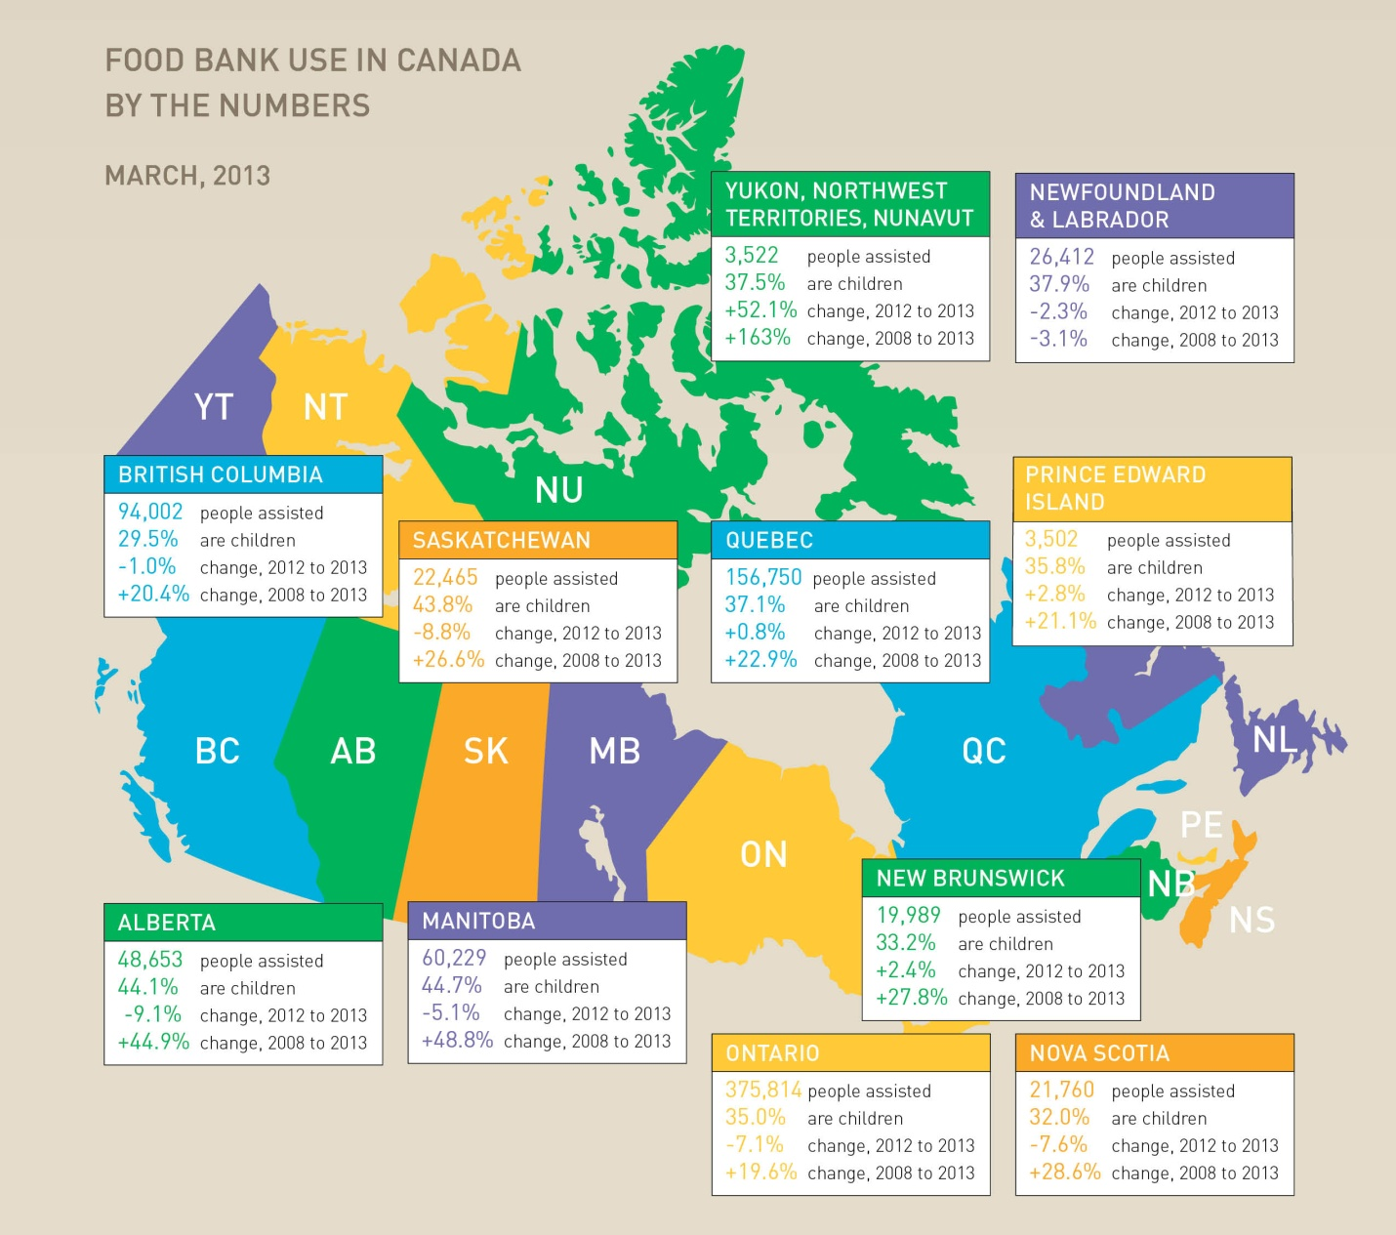

1. Identify four provinces/territories in which the use of food banks increased (went up) since 2012:
_________________________________________
_________________________________________
_________________________________________
_________________________________________
2. Identify four provinces/territories in which the use of food banks decreased (went down) since 2012:
_________________________________________
_________________________________________
_________________________________________
_________________________________________
3. How does this map of food bank use show how some Canadians are disempowered?
_______________________________________________________________________________________________________________________________________________________________________________________________________________________________________________________________
4. How do food banks help empower those who cannot afford to fulfill some of their basic needs?
_______________________________________________________________________________________________________________________________________________________________________________________________________________________________________________________________
Find the province/territories with the highest population who claim to use food banks:
Example 94002 $÷$ 4 582 000= 0.020515... x100= 2.05%
Answer: __________________________________________________

