Changing Your World: Introduction
Once you have defined empowerment, you must gain some basic knowledge that will help you understand our future studies in this class. After you complete this page, I have some activities for you to move onto. The following information can be found on page 4 to 15 of the textbook. Refer to the headlines I provide with hints as to where you can find the answers.

Authority and Power

What are some characteristics of people who feel empowered? Write your ideas in the figure below!
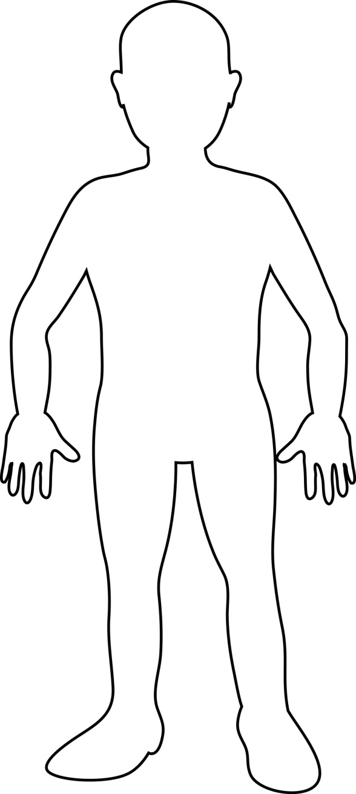

Authority is ______________________________________________________________________________ _____________________________________________________________________________________________________________________

Examples/Types of Authority
- Refer to the textbook and come up with your own!

Authority Gives People Power
Define constitution: ____________________________________________________________________ _____________________________________________________________________________________
How do the constitution and the Canadian Charter of Rights and Freedom give people power?
____________________________________________________________________________________________________________________________________________________________________________________________________________________________________________________________________________________________________________________________________________________

Authority and Power in Your Life
Give examples of people who have power/authority in your life:

Give examples of how you have power/authority in your life: | Give examples of how you lack power/authority in your life:

What is PERSONAL EMPOWERMENT?
_______________________________________________________________________________________________________________________________________________________________________________________________________________________________________________________________
Examples of Personal Empowerment | Examples of Personal Empowerment in YOUR Life

The following headings will be the units for the year. To get started, I want you to review the explanations in the first chapter and sum up in two to three sentences what you predict that unit to be about.

Economic Empowerment
____________________________________________________________________________________________________________________________________________________________________________________________________________________________________________________________________________________________________________________________________________________

Political Empowerment
____________________________________________________________________________________________________________________________________________________________________________________________________________________________________________________________________________________________________________________________________________________

Cultural Empowerment
____________________________________________________________________________________________________________________________________________________________________________________________________________________________________________________________________________________________________________________________________________________

Economic Empowerment
____________________________________________________________________________________________________________________________________________________________________________________________________________________________________________________________________________________________________________________________________________________

Societal Empowerment
____________________________________________________________________________________________________________________________________________________________________________________________________________________________________________________________________________________________________________________________________________________

National Empowerment
____________________________________________________________________________________________________________________________________________________________________________________________________________________________________________________________________________________________________________________________________________________

DISEMPOWERMENT
Define DISEMPOWERMENT: ______________________________________________________________ __________________________________________________________________________________________________________________________________________________________________________
What is meant by the term HUMAN RIGHTS?
____________________________________________________________________________________________________________________________________________________________________________________________________________________________________________________________________________________________________________________________________________________
Why are children easily disempowered?
_______________________________________________________________________________________________________________________________________________________________________________________________________________________________________________________________

Can you think of any examples of how children/youth have been or are currently disempowered?
_______________________________________________________________________________________________________________________________________________________________________________________________________________________________________________________________

