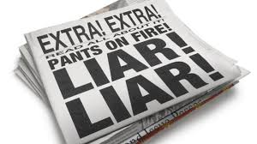
Writing A Fake News Article

We have been hearing a lot about “Fake News” these days… so, in an effort to better understand what Fake News is and
how it works, YOU are going to try your hand at being a Fake News Journalist.

Your tasks:

Read at least two REAL newspaper articles. You may choose to go to thechronicleherald.ca, theglobeandmail.com, or one of the two links offered on my website. You must fill out the graphic organizer with the information from the article: Who, What, When, Where, Why & How. This will show you how to write a newspaper article with all of the necessary information. It will also give you ideas on what your own fake news article should/could include!

Compose a Fake News article. Start by using a THIRD graphic organizer to plan out your ideas, ensure that you include what a real newspaper article would have - Who, What, When, Where, Why & How. Tell plenty of lies. Make it all up: site fake research, quote fake experts. But it’s imperative that you sound legitimate. Include at least one quote from an expert. The expert will depend on the news story.

You should also use the fake articles we looked at in class, published by the Manatee as inspiration! As you read them, you likely questioned them, yet the articles were well-written, seemed to have experts sharing their knowledge and included some actual events.

Do not forget to revise and edit!!!

What | Who | When | Where | Why/How

