Grade 7/8 IBL: Heritage Fair Proposal
Please complete the following proposal before the holiday break and have it signed by a parent/guardian. You may not begin this IBL module until this sheet is complete and signed off on by your teacher.

Name(s): __________________________

Topic Title (can change): ___________________________________________________

Topic you will be investigating (Is it an event? Person?Organization? Building?): _____________________________________________________________________________________
_____________________________________________________________________________________
_____________________________________________________________________________________

Brief summary of your research will include (what you will be presenting) :
_____________________________________________________________________________________
_____________________________________________________________________________________
_____________________________________________________________________________________
_____________________________________________________________________________________
_____________________________________________________________________________________
_____________________________________________________________________________________

Materials you will need and where you will get them from:
_____________________________________________________________________________________
_____________________________________________________________________________________
_____________________________________________________________________________________
Sources you will need and where you will get them from (People? Websites?Books?Newspaper articles? Other?):
_____________________________________________________________________________________
_____________________________________________________________________________________
_____________________________________________________________________________________
What props, artifacts or other items will you be including in your project?
_____________________________________________________________________________________
_____________________________________________________________________________________

___________________________________________________________________________________
Example of a 3-sided Poster Board

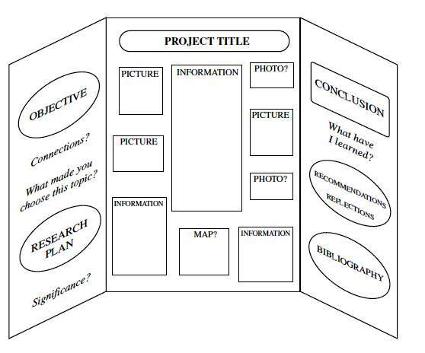

Parent/Guardian Signature: __________________________________

Teacher Signature: __________________________________________

