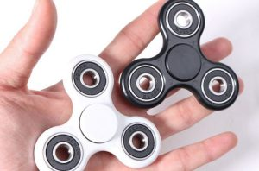
NB Power: 40% of power to

come from fidget spinners by

2019
¹

POSTED BY SHAWN ROUSE

Fredericton — While many are focussed on tidal, solar and wind turbines as energy sources of the future, NB Power is now turning its attention to green energy generation efforts from another natural source — the boundless energy of children.
President and CEO Gaëtan Thomas announced today that the future of renewable energy in New Brunswick is to harvest the generation of electricity using a modified version of the fidget spinner. NB Power has patented the technology, and has started manufacturing them overseas. The first shipment will arrive at New Brunswick schools at the end of this month.
“It’s not that there’s anything particularly interesting, innovative or even fun about fidget spinners,” said Thomas. “But, it’s the only toy that children are allowed to play with during class. Our focus groups show that children would play with a pile of mashed potatoes in class if they were allowed… anything to distract them from the lesson. Using our plan, we can capitalize on this fad and reduce our generation requirements.”
The modified spinner from NB Power uses common electromagnetic principles to create electricity. Electromagnetic induction is created by the spinning of the toy around a core as described by Faraday’s Law of Induction. Essentially, the spinners become mini-dynamos capable of charging mobile devices, laptops and other low voltage electronic devices.
Thomas continued, “We figured that as long as children are going to be endlessly spinning these ridiculous things at school all day anyway, we might as well get some good from it. They will be able to charge their own USB-based devices, potentially saving millions in required generation. If these trends continue, we could see up to 40 percent of our power generation coming from these strange doo-hickeys by 2019.”
The Manatee asked Thomas how NB Power plans to bridge the gap between micro-generators and gigawatts of required capacity, but he had stopped listening and was totally consumed by watching a spinner rotate in his hand.

http://themanatee.net/nb-power-40-of-power-to-come-from-fidget-spinners-by-2019/

