Reining in school bullies
THE CHRONICLE HERALD
Published May 4, 2015 - 1:00am
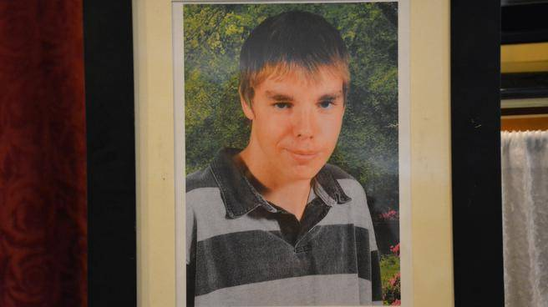
The death of Christopher Chafe of Sydney, who was hit by a school bus at Sydney Academy in February, raises serious issues about bullying and the responsibility of schools to keep kids safe.
A 15-year-old boy now faces charges of criminal negligence causing death.
In an email to reporters, Noel Chafe, Christopher’s father, said he reported a Facebook death threat against his son to police, who told him the situation had been dealt with and that Christopher “would be safe to go to school.” His son was the victim of repeated bullying, Mr. Chafe said.
In 1991, Hedy Van Gurp lost her son Ben, then 14, when he died of injuries after being pushed to the ground by a student who had bullied him. The Nova Scotia woman went on to found Peaceful Schools International, which works with schools to promote peace.
Bullying is a complex social problem with no simple, one-size-fits-all solution.
But we know that it can cause both physical and psychological harm, particularly to children. It can be an issue in teen depression, which, in turn, is a risk factor for suicide.
Parents of students who are being harassed have long complained that their children, not bullies, usually end up leaving school and starting over elsewhere.
For their part, schools, administrators and teachers say that while they promote a safe environment, they are primarily educators. Most report they don’t have the resources to deal with bullying or cyberbullying, particularly when it occurs off school property.
Given the potential harm bullying can cause, we believe the school system must do more. In Nova Scotia, sending children to school is not really a choice for most parents, who trust schools to take care of their children in their absence.
Before children can learn, they must be physically and psychologically safe. Serious bullying allegations are, or should be, referred to police, but school staff also need adequate training and resources to deal with bullying.
Some provinces do more to ensure student safety. In Ontario, schools can discipline for incidents off school property that affect the school environment. School boards are required to develop guidelines on bullying, incidents of repeated or severe bullying are grounds for expulsion and school boards must assist students in promoting gender equity, anti-racism, and LGBT/gay-straight alliances, in order to support students at higher risk of harassment.
Simply getting tough with confirmed bullies does not solve the problem. They, too, need help: to change their behaviour so they can stay in school and become productive members of society. Their parents must step up to own this problem, too.
When responsible adults turn a blind eye to bullying, we teach all our children that it pays to misbehave — a life lesson that will turn out badly for them in the world be-yond school.
Implementing other measures, as Ontario has done, and removing chronic bullies from schools to keep our children safe, are good starts.

