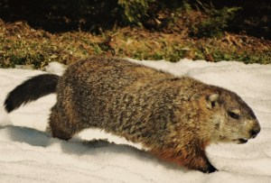
Thousands of groundhogs found dead in New Brunswick
⁰
^{April 20, 2017}

POSTED BY MANATEE STAFF

New Brunswick — SPCA branches as well as police officers are baffled this morning as thousands of groundhogs have been found dead in cities and towns all across New Brunswick.

“It’s very early in the investigation, but we can say with certainty that the deaths were not of natural causes,” said a mournful Const. Jeff McKnight of Fredericton Police, “but the groundhogs were deliberately murdered.”
Officials refused to speculate as to whether the killings were any way related to the five centimetres of snow that fell across the province Wednesday night.
An obviously fed-up John Forgeron of Fredericton, who was brushing snow from his buried car this morning, believes it was.
“When people have finally had enough, they need someone to blame,” he said, scraping his windshield. “And when some stupid little rodent deliberately lies to our faces and says he didn’t see his shadow and winter is coming to an end, we can’t really be held accountable for what happens.”
After hearing of the massacre in New Brunswick, officials in Nova Scotia quickly put Shubenacadie Sam in protective custody. “All we can tell you is that he is in an unassailable location under 24/7 protection,” said Sam’s full-time security guard.
“Obviously he’s pretty shaken up, but we’ve been doing everything possible to make him feel safe.”

